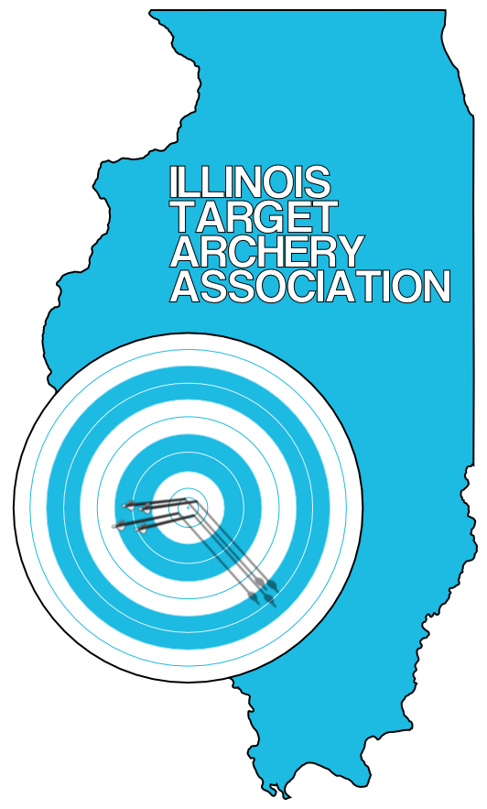
ILLINOIS TARGET ARCHERY ASSOCIATION
AUGUST 11 & 12, 2012
ITAA OUTDOOR STATE CHAMPIONSHIP – 900 METRIC ROUND
The 2012 Illinois Target Archery Association Outdoor State Championship will be held this year at the Wheaton Rifle Club on the weekend of August 11th and 12th. This year’s tournament will be a sanctioned “STAR FITA” event. Bow styles and age divisions will all comply with USA Archery guidelines.

Schedule:

Saturday, August 11th: Bowman, Cub, and Female Cadet State Championship 900 Metric Round. 8:00 AM check in and practice. 9:00 AM scoring begins. The format for cubs and female cadets will be thirty arrows each at 40M, 30M and 20M for a total of ninety scored arrows. The format for bowman will be thirty arrows each at 30M, 25M and 20M. The 122cm FITA target face will be used at all distances.

Saturday, August 11th: JOAD Star Pin Qualifier. 12:30 PM check in and practice. 1:00 PM scoring. We are aware that there are so many new shooters joining JOAD clubs that we want to give novice shooters the experience of earning their first JOAD Star Pins while shooting in a state championship atmosphere. Targets will be set at 15M, 20M, 25M, and 30M as needed. The qualifying round will consist of 36 arrows. To be eligible for a JOAD Star Pin, an archer must be a current member of a JOAD Club.

Sunday, August 12th: Male Cadet, Junior, Senior, and Master State Championship 900 Metric Round.
8:00 AM check in and practice. 9:00 AM scoring begins. The format will be thirty arrows each at 60M, 50M and 40M for a total of ninety scored arrows. The 122cm FITA target face will be used at all distances.

Pre-registration and Tournament Fee: Registration is required in advance since each shooting line can only accommodate a total of twenty-eight archers. Registration can be done online at www.illinoistargetarchery.org Deadline for registration is August 10th to guarantee your spot on the shooting line. The state championship tournament fee is $25 for adults, $20 for youth. There is a family maximum fee of $50. The JOAD Qualifier fee is $12.50. ITAA shoots are open to any interested participants, regardless of NAA/NFAA/IBO affiliation. Non-members may also participate.
ITAA Membership Meeting: The ITAA will hold a general membership meeting, beginning approximately at 12:30 PM on Sunday. The agenda will not exceed 30 minutes. Anyone can attend the meeting. If issues come to vote, voters must be 18 years of age, an Illinois resident, and hold USA Archery member status.
Location and Accomodations: The Wheaton Rifle Club is located at: 27W070 North Ave., West Chicago, Illinois. It is on the north side of North Ave (Rt. 64), four buildings east of County Farm Road. Concession food and beverage items, including lunch, will be available for purchase.
Awards: State Championship Medals will be awarded for first, second, and third place in each division. JOAD Star Pins and Lanyards will be awarded if the qualifying score is met. The scoring matrix for Star Pins can be viewed at http://www2.teamusa.org/USA-Archery/Programs/Junior-Olympic-Archery-Development/JOAD-Award-System.aspx . Please note…if you are planning to shoot for a JOAD Star Pin, the morning round score will not count toward your pin since only 30 arrows will be scored at each distance. 36 are required for the star pin.
Additional Information: Tom Havel at tbhavel@comcast.net

